Project Design Phase
Solution Architecture

Date | 20 February 2026
Team ID | LTVIP2026TMIDS89328
Project Name | Online payments fraud detection using machine learning
Maximum Marks | 4 Marks

Solution Architecture:
Solution architecture for Online Payments Fraud Detection using Machine Learning connects the business need for secure transactions with a reliable technical solution. Its goals are to:
● Design a scalable system to detect fraud in real time.
● Define the structure of components like data processing, ML model, and decision engine.
● Identify key features such as fraud scoring and alerts.
● Outline development phases from training to deployment.
● Provide clear technical specifications for implementation and maintenance.

Example - Solution Architecture Diagram:

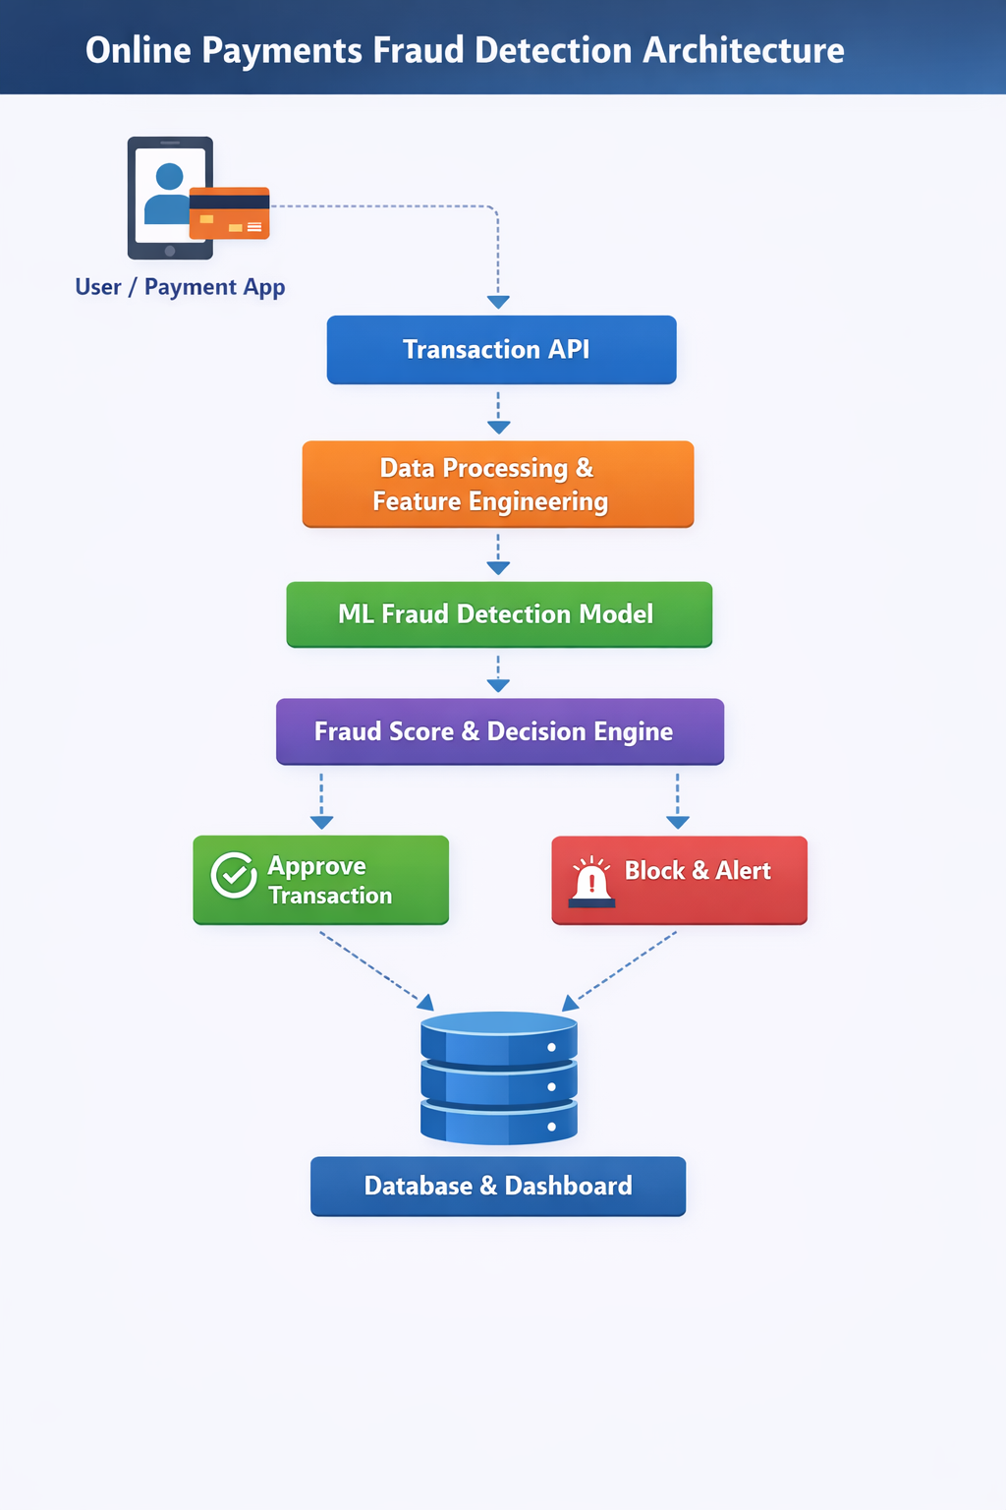
Figure 1: Architecture and data flow of the voice patient diary sample application
Reference:https://aws.amazon.com/blogs/machine-learning/real-time-fraud-detection-using-aws-serverless-and-machine-learning-services/

